## Que.Create a Book and Member Table for Library Management System

1. **Book Table:**

Create table Book1

(Book_id number(10), book_name varchar(20), author varchar(20),

publication_year number(10));

## Output:

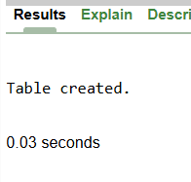

1. **Member Table**

Create table Member1

(Member_id number(10), name varchar(20),

email varchar(20));

## Output:

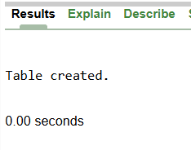

**Que. Insert the Records into Book and Member Table. 1:Insert into Book table:**

INSERT INTO Book1 (Book_id, book_name, author, publication_year) VALUES (1, 'The Great Gatsby', 'F. Scott Fitzgerald', 1925);

INSERT INTO Book1 (Book_id, book_name, author, publication_year) VALUES (2, '1984', 'George Orwell', 1949);

INSERT INTO Book1 (Book_id, book_name, author, publication_year) VALUES (3, 'To Kill a Mockingbird', 'Harper Lee', 1960);

INSERT INTO Book1 (Book_id, book_name, author, publication_year) VALUES (4, 'Pride and Prejudice', 'Jane Austen', 1813);

INSERT INTO Book1 (Book_id, book_name, author, publication_year) VALUES (5, 'The Catcher in the Rye', 'J.D. Salinger', 1951);

INSERT INTO Book1 (Book_id, book_name, author, publication_year) VALUES (6, 'Moby Dick', 'Herman Melville', 1851);

INSERT INTO Book1 (Book_id, book_name, author, publication_year) VALUES (7, 'War and Peace', 'Leo Tolstoy', 1869);

INSERT INTO Book1 (Book_id, book_name, author, publication_year) VALUES (8, 'Brave New World', 'Aldous Huxley', 1932);

INSERT INTO Book1 (Book_id, book_name, author, publication_year) VALUES (9, 'The Odyssey', 'Homer', 800);

INSERT INTO Book1 (Book_id, book_name, author, publication_year) VALUES (10, 'The Picture of Dorian Gray', 'Oscar Wilde', 1890);

## Select Book table:

select * from Book1

## 1:Insert into Member table:

INSERT INTO Member1 (Member_id, name, email) VALUES (1, 'John Doe', 'john.doe@example.com');

INSERT INTO Member1 (Member_id, name, email) VALUES (2, 'Jane Smith', 'jane.smith@example.com');

INSERT INTO Member1 (Member_id, name, email) VALUES (3, 'Alice Johnson', 'alice.johnson@example.com');

INSERT INTO Member1 (Member_id, name, email) VALUES (4, 'Bob Brown', 'bob.brown@example.com');

INSERT INTO Member1 (Member_id, name, email) VALUES (5, 'Carol White', 'carol.white@example.com');

INSERT INTO Member1 (Member_id, name, email) VALUES (6, 'David Wilson', 'david.wilson@example.com');

INSERT INTO Member1 (Member_id, name, email) VALUES (7, 'Eva Green', 'eva.green@example.com');

INSERT INTO Member1 (Member_id, name, email) VALUES (8, 'Frank Blue', 'frank.blue@example.com');

INSERT INTO Member1 (Member_id, name, email) VALUES (9, 'Grace Black', 'grace.black@example.com');

INSERT INTO Member1 (Member_id, name, email) VALUES (10, 'Henry Red', 'henry.red@example.com');

## Select member table:

select * from member

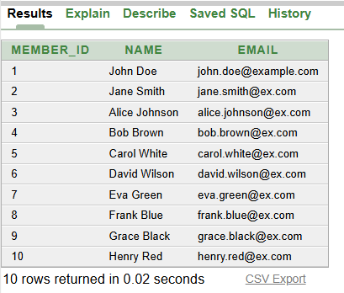

## Que.Perform Update Query in Book and Member Table.

1. **Update Query on Book table**

UPDATE Book1

SET book_name = 'Macbeth', publication_year = 1983 WHERE Book_id = 4;

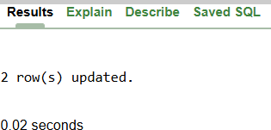

## Select Query:

Select * from Book1

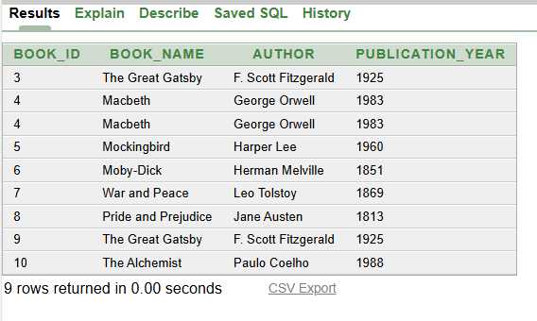

## Update Query on Member table

UPDATE Member1

SET name = 'Sakshi', email = 'sakshi@gmail.com' WHERE Member_id = 1;

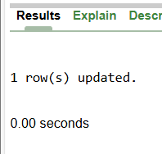

## Que.Write SQL statement to make use of all phases of select commands

### SELECT

b.book_name, b.author,

COUNT(m.member_id) AS member_count FROM

Book1 b LEFT JOIN

Member1 m ON b.book_id = m.member_id WHERE

b.publication_year >= 1925 GROUP BY

b.book_name, b.author HAVING

COUNT(m.member_id) > 0 ORDER BY

b.book_name ASC;

**Output:**

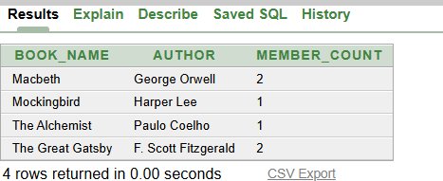

## Que.Write SQL Statement by using Oracle functions.

1. **Count the Number of Books:**

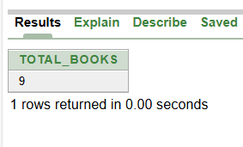SELECT COUNT(*) AS Total_Books FROM Book1;

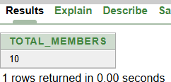SELECT COUNT(*) AS total_members FROM Member1;

## Concatenate Name and Email of Members

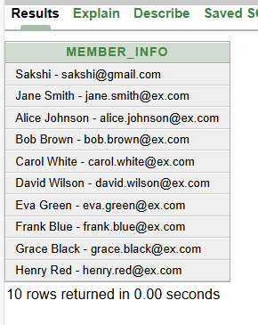SELECT name || ' - ' || email AS member_info FROM Member1;

1. **Get members whose names start with a specific letter (e.g., 'A')**: SELECT * FROM Member1 WHERE UPPER(name) LIKE 'A%';

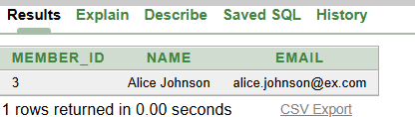

## Retrieve Members with Emails in Uppercase

SELECT Member_id, Name, UPPER(Email) AS Uppercase_Email FROM Member1;

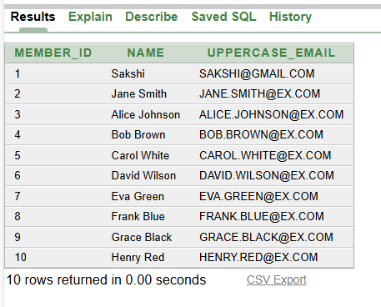

## List Book Titles with Length Greater Than 10 Characters

SELECT Book_name FROM Book1 WHERE LENGTH(Book_name) > 10;

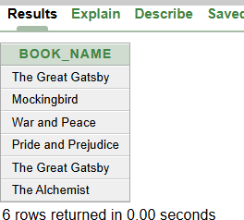

# ASSIGNMENT :6

## Que.Create view by using table book an member perform select ,update,delete operation

CREATE VIEW BookMemberView AS SELECT

B.Book_id, B.book_name, B.author,

B.publication_year, M.Member_id, M.name,

M.email

FROM Book1 B JOIN

Member1 M ON B.Book_id = M.Member_id;

**Output:**

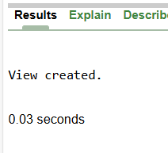

## Update Operation

UPDATE Member1 SET Email = 'sakshi@gmail.com' WHERE Member_id = 1;

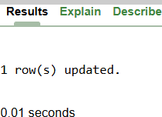

## Select operation

SELECT * FROM BookMemberView;

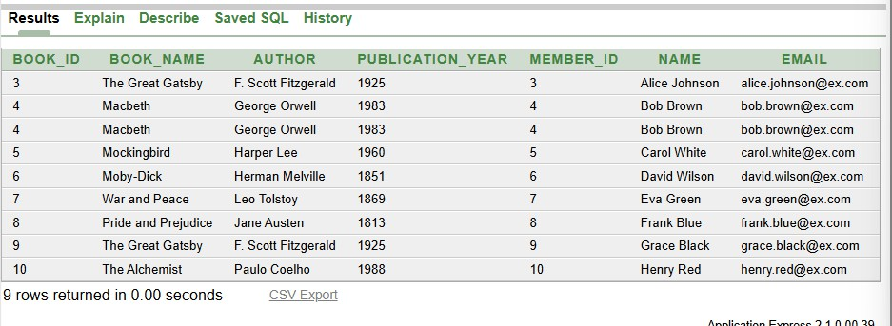

## Delete Operation:

DELETE FROM Book1 WHERE Book_id = 3;

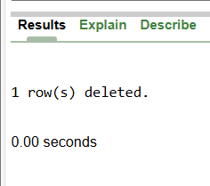

## Que. write a sub query for the book and member table for library

* 1. **Sub Query**

SELECT name, email FROM member

WHERE member_id IN ( SELECT member_id

FROM Book

WHERE Book_id = (SELECT Book_id FROM book WHERE publication_year=2021)

);

## Output:

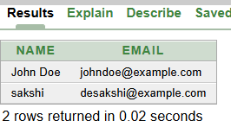

* 1. **Sub Query**

SELECT book_id, title, author, publication_year FROM Book

WHERE author IN (SELECT name FROM Member);

## Output:

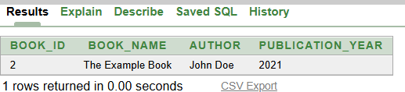

**Que. write a PL/SQL by using if statement to display squares of all odd numbers between 1 to 25**

### BEGIN

FOR i IN 1..25 LOOP

-- Check if the number is odd IF MOD(i, 2) = 1 THEN

-- Display the square of the odd number

DBMS_OUTPUT.PUT_LINE('Square of ' || i || ' is : ' || i * i); END IF;

END LOOP; END;

**Output:**

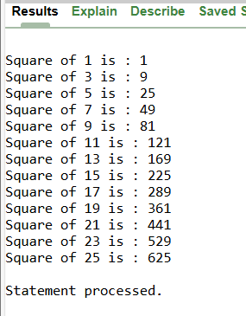

**Que. write a PL/SQl to implement while loop for library table.**

1. **Library Table**

CREATE TABLE library (

book_id NUMBER PRIMARY KEY, title VARCHAR2(255),

author VARCHAR2(255), available_copies NUMBER

);

## Insert Into Library

INSERT INTO library (book_id, title, author, available_copies) VALUES (1, '1984', 'George Orwell', 5);

INSERT INTO library (book_id, title, author, available_copies) VALUES (2, 'To Kill a Mockingbird', 'Harper Lee', 3);

## While loop

### DECLARE

v_book_id NUMBER; v_title VARCHAR2(255);

v_author VARCHAR2(255); v_available_copies NUMBER;

CURSOR c_library IS

SELECT book_id, title, author, available_copies FROM library

WHERE available_copies > 0;

v_counter NUMBER := 0; BEGIN

OPEN c_library;

### LOOP

FETCH c_library INTO v_book_id, v_title, v_author, v_available_copies; EXIT WHEN c_library%NOTFOUND; -- Exit condition for the loop

-- Process the fetched data (in this case, print it)

DBMS_OUTPUT.PUT_LINE('Book ID: ' || v_book_id || ', Title: ' || v_title ||

', Author: ' || v_author ||

', Available Copies: ' || v_available_copies);

v_counter := v_counter + 1; END LOOP;

CLOSE c_library;

-- Optional: Print the total count of books processed

DBMS_OUTPUT.PUT_LINE('Total books with available copies: ' || v_counter); END;

/

## Output:

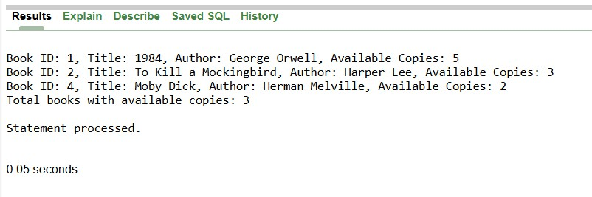

**Que. write a PL/SQl to implement For loop for library table**

### DECLARE

-- Declare a cursor to fetch data from the library table CURSOR library_cursor IS

SELECT book_id, title, author, available_copies FROM library;

### BEGIN

-- Loop through each record fetched by the cursor FOR book_record IN library_cursor LOOP

-- Output the details of each book

DBMS_OUTPUT.PUT_LINE('Book ID: ' || book_record.book_id || ', Title: ' || book_record.title ||

', Author: ' || book_record.author ||

', Available Copies: ' || book_record.available_copies);

END LOOP;

END;

## Output:

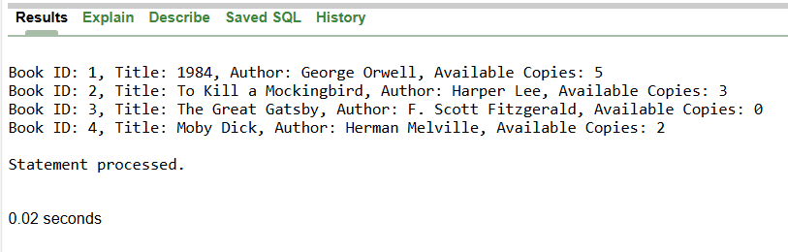

**Que.Implement Error handling in Pl/SQL for library Book Table.**

### DECLARE

v_Book_id NUMBER := 101; -- Example book ID

v_Book_name VARCHAR2(100) := 'The Great Gatsby'; -- Example title v_Author VARCHAR2(100) := 'F. Scott Fitzgerald'; -- Example author

v_Publication_Year NUMBER := 1925; -- Example year BEGIN

-- Attempt to insert a new book record

INSERT INTO Book (Book_id, Book_name, Author, Publication_Year) VALUES (v_Book_id, v_Book_name, v_Author, v_Publication_Year);

DBMS_OUTPUT.PUT_LINE('Book record inserted successfully.'); EXCEPTION

### WHEN DUP_VAL_ON_INDEX THEN

DBMS_OUTPUT.PUT_LINE('Error: Book ID already exists.');

### WHEN VALUE_ERROR THEN

DBMS_OUTPUT.PUT_LINE('Error: Invalid value for one of the fields.'); WHEN OTHERS THEN

DBMS_OUTPUT.PUT_LINE('An unexpected error occurred: ' || SQLERRM); END**;**

**Output:**

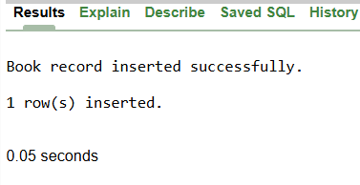

## Que. write a PL/SQl to implement Procedure For the Given Table

CREATE OR REPLACE PROCEDURE insert_book_and_member ( p_book_id IN NUMBER,

p_book_name IN VARCHAR2, p_author IN VARCHAR2,

p_publication_year IN NUMBER, p_member_id IN NUMBER, p_name IN VARCHAR2,

p_email IN VARCHAR2

### ) AS BEGIN

-- Insert into the Book Table

INSERT INTO Book (Book_ID, book_name, Author, publication_year) VALUES (p_book_id, p_book_name, p_author, p_publication_year);

-- Insert into the Member Table

INSERT INTO Member (Member_ID, Name, email) VALUES (p_member_id, p_name, p_email);

-- Commit the transaction COMMIT;

### END;

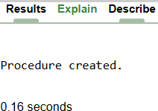**Output:**

### BEGIN

insert_book_and_member( p_book_id => 1,

p_book_name => 'The Great Gatsby', p_author => 'F. Scott Fitzgerald', p_publication_year => 1925,

p_member_id => 101, p_name => 'John Doe',

p_email => 'johndoe@example.com'

### ); END;

**Output:**

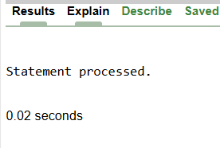

# ASSIGNMENT :13

## Que. write a PL/SQl to create and manage cursor for Book Table

### DECLARE

-- Cursor to fetch Book table details CURSOR book_cursor IS

SELECT Book_ID, book_name, Author, publication_year FROM Book;

-- Variables to hold book details fetched from the cursor v_book_id Book.Book_ID%TYPE;

v_book_name Book.book_name%TYPE; v_author Book.Author%TYPE;

v_publication_year Book.publication_year%TYPE;

### BEGIN

-- Open the cursor OPEN book_cursor;

-- Loop through each row fetched by the cursor LOOP

FETCH book_cursor INTO v_book_id, v_book_name, v_author, v_publication_year;

-- Exit the loop when no more rows are fetched EXIT WHEN book_cursor%NOTFOUND;

-- Display the book details

DBMS_OUTPUT.PUT_LINE('Book ID: ' || v_book_id || ', Name: ' || v_book_name || ', Author: ' || v_author || ', Year: ' || v_publication_year);

### END LOOP;

-- Close the cursor CLOSE book_cursor; END;

**Output:**

